Whole Game Project Summary
For the Whole Game Project, I brainstormed and planned how to approach the project and data before working on it. My plan is to scan the data, import the data table, clean the data, and answer the questions using a mixer of visualizations and supporting data. I anticipate there will be problems with missing values that will require judgment and explanations. The SOAR Methodology will be useful in making a structured format for answer the questions.
The first step I wrote down was to understand the what and the why of the project. I tried to find out what the end goal of the project was to increase efficiency and reduce misunderstandings. The next thing I did was scan the data to see if there are any concerns or issues that need to be corrected. For example, one of the main problems is the invoice number of the data was missing value. Since the invoice number variable acted as the unique identifier of the data table, I had to drop all the rows that had missing values in the column. The next step was to import the data and create a data dictionary. After importing the data, I cleaned up the data by dropping the rows that contained NA’s in the invoice number column and renaming the columns. The last step was to answer the questions using functions that transform rows and columns and create simple visualizations.
After completing my analysis, I found that Rapido seems to be the best carrier at limiting costs while still completing a high number of shipments. Rapido has the most shipments, the lowest average cost per shipment, the second lowest cost per KG-KM, and seems to have a lower cost based on delivery time compared to some of the other carriers. These results could change if the dataset contains all the values for the carriers. The results can still be utilized as there are only 20 missing values out of 446, which is only 4% of the data.

For question one, I arranged the days from smallest to biggest to find a trend in the data. Next, I created a scatter plot of the relationship between ‘Cost’ and ‘Days’ through a linear regression line. The results show that there is a positive correlation between the delivery time and days
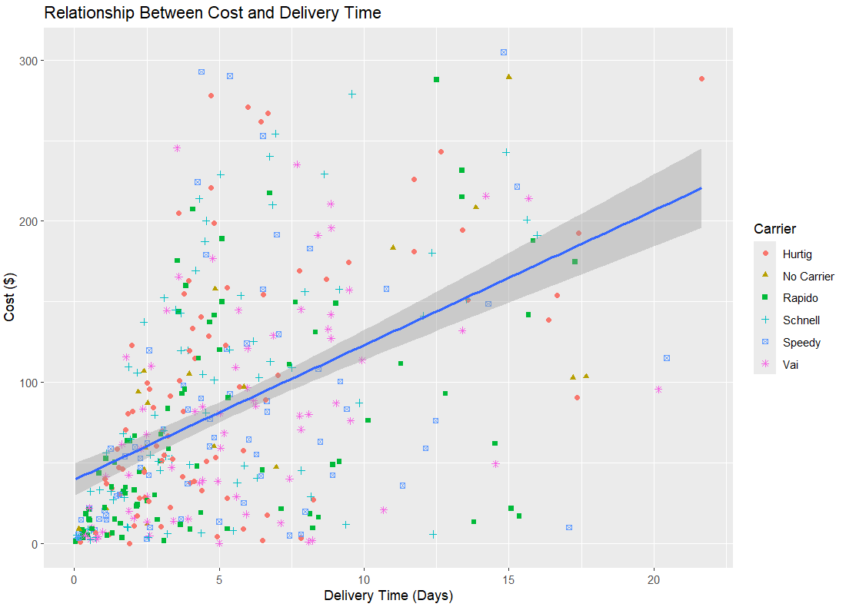

For question two, I counted the number of shipments by carrier. I then created a bar graph that shows the difference between carriers. I left the missing values in the analysis but identified them as ‘No Carrier’. The results show that Rapido has the most shipments while the other carriers are similar to each other.
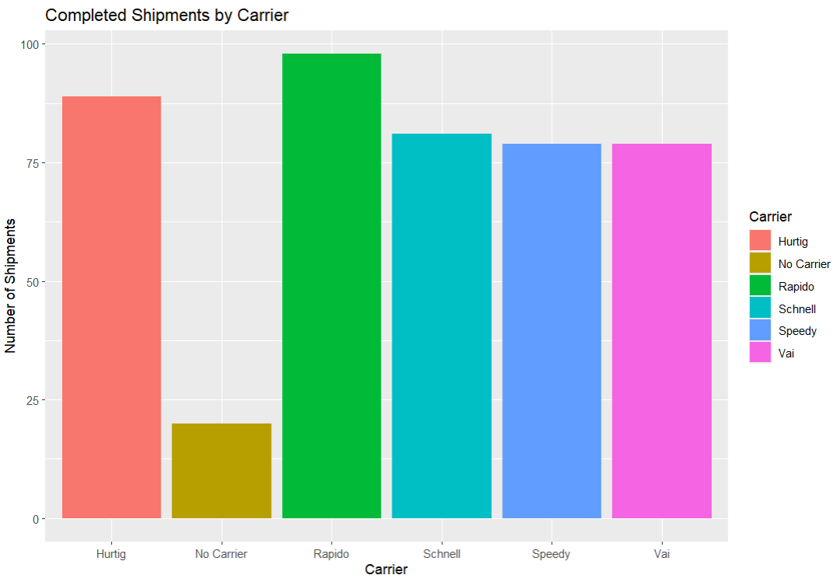

For question three, I created a variable that took the mean of the cost per shipment grouped by carrier. I then created a bar chart that shows the average cost of a shipment by each carrier. I left the missing values in the analysis but identified them as ‘No Carrier’. The results show that Hurtig has the highest average cost per shipment while Rapido has the lowest.
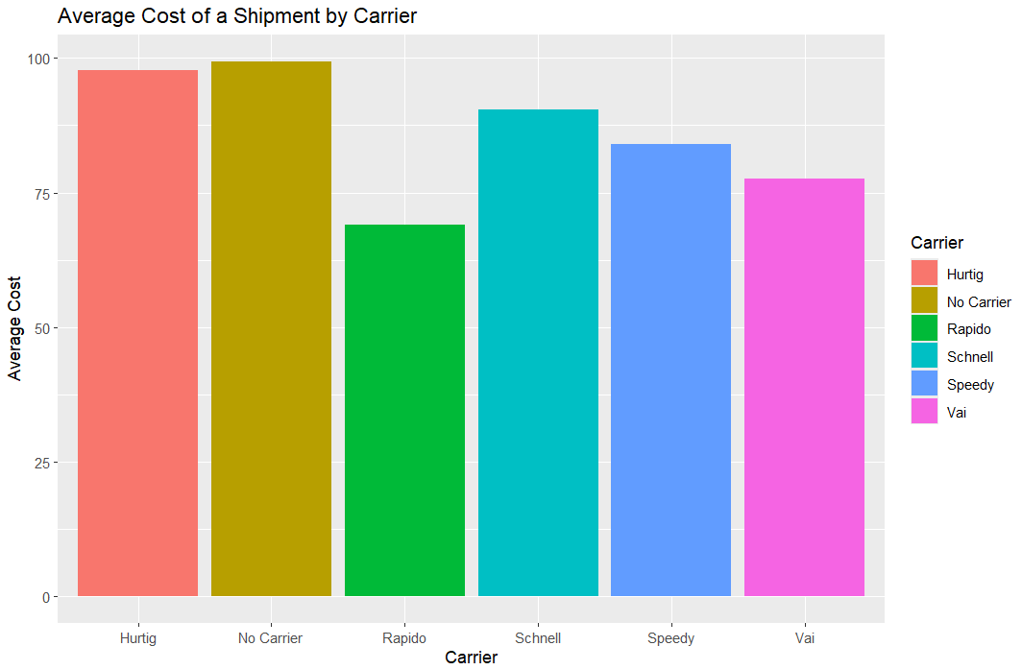
For questions four, I created a variable the finds the cost per KG-KM for all carriers. I did this by taking the total cost divided by the total KG-KM while using the summarize function. I also used the filter function to make sure I was not dividing by zero in the calculation. There was no need for visualization because the result was only three values. The average cost per KG-KM for all carriers is 0.00932.

For question five, I identified the rank for each carrier by cost per KG-KM. I used the same code from above except I changed the variable name and added the “grouped_by” function to show the rank by carrier. We can see that Hurtig has the highest cost per KG-KM while Speedy has the lowest followed by Rapido.
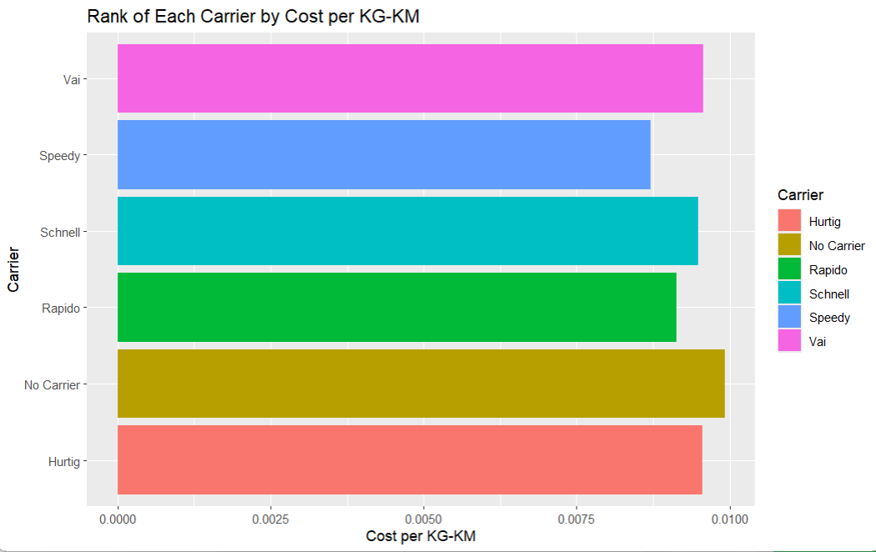

For question six, I created a scatter plot that plots the data of ‘Longest diagonal’ and ‘Cost’ then ran a linear regression line to show the relationship between the two. The results show that there is a slight negative correlation between ‘Longest diagonal’ and ‘Cost’. However, it is not a strong correlation between the two.
